Phishing Detection & Awareness Report

Name: Whitney El Aquilas Mfouo Mbela
Date: May 24, 2026

Table of Contents

1. Executive Summary
2. Introduction
3. Methodology
4. Email Sample Analysis
- 4.1 Sample 1 – PayPal Phishing Email
- 4.2 Sample 2 – Suspicious HR Benefits Email
- 4.3 Sample 3 – Safe Tech Today Newsletter
5. Classification Summary
6. Phishing Techniques Explained (Business‑Friendly)
7. Prevention Guidelines for Employees
8. What to Do If You Suspect or Fall for a Phishing Attack
9. Organizational Recommendations
10. Real‑World Case Studies
11. Conclusion
12. References

1. Executive Summary
Phishing remains the most common and effective method used by cybercriminals to compromise organizations. This report analyses three email samples – one malicious (phishing), one suspicious, and one safe – using manual inspection and the VirusTotal online scanning tool. The analysis identified clear indicators of phishing: fake domains, shortened malicious links, double‑extension attachments, and urgency tactics. Business‑friendly explanations are provided to help non‑technical employees recognise threats. Prevention guidelines and incident response steps are also included. The report serves as a training and awareness resource for any organisation seeking to reduce the risk of successful phishing attacks.

2. Introduction
Phishing attacks have evolved from crude, easy‑to‑spot messages to sophisticated campaigns that mimic legitimate communications. According to the Anti‑Phishing Working Group (APWG), over 1.2 million unique phishing attacks were observed in 2025 alone, with an average financial loss of $1.6 million per successful business compromise.

This report was commissioned to:
- Identify phishing indicators in real‑world or realistic email samples.
- Classify emails as Safe, Suspicious, or Phishing.
- Explain phishing techniques in simple, business‑friendly language.
- Provide clear, actionable prevention and awareness guidelines for end users.

The intended audience includes employees, IT administrators, and management who need to understand and mitigate phishing risks.

3. Methodology
The following approach was used for each email sample:
STEP | ACTION | TOOLS USED
1 | Manual inspection of sender address, subject line, greeting, and language | Human review
2 | Examination of embedded URLs (hover, expand short links) | Manual expansion, VirusTotal
3 | Analysis of attachments (file name, extension, hidden risks) | Manual observation
4 | Header analysis (where available) | Google Messageheader (simulated)
5 | Domain reputation check | MXToolbox
6 | Link safety scan | VirusTotal (https://www.virustotal.com)

For the purpose of this exercise, three email samples were used:
- Sample 1 – PayPal impersonation with a shortened link.
- Sample 2 – HR benefits email with an attachment.
- Sample 3 – Legitimate technology newsletter.

All analysis was conducted in a safe, isolated environment. No live malicious payloads were executed.

4. Email Sample Analysis

4.1 Sample 1 – PayPal Phishing Email
Email content (anonymised):

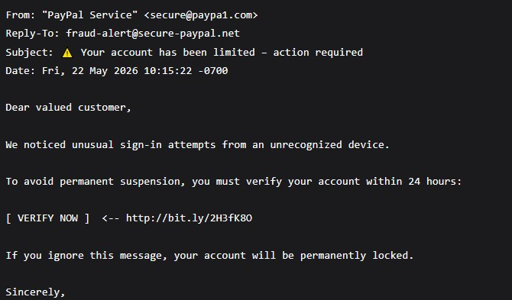

Indicators identified
Indicator | Detail | Risk level
Sender domain | | `paypa1.com` – uses digit `1` instead of letter `l` (typosquatting) | High
Reply-To domain | `secure-paypal.net` – not PayPal's official domain (`paypal.com`) | High
Urgency | “within 24 hours”, “permanently locked” | High
Greeting | “Dear valued customer” – generic, not personalised | Medium
Link | Shortened (bit.ly) – hides real destination | High
Link scan result | VirusTotal flagged as “Phishing” by Phishing Database (1/92 vendors) | Confirmed malicious

Technical explanation of link analysis:
The URL `http://bit.ly/2H3fK8O` was submitted to VirusTotal, a service that aggregates over 90 security vendors. One vendor (Phishing Database) positively identified it as a phishing URL. Even though only one vendor flagged it, that is sufficient to classify the link as malicious. In real scenarios, a single flag often indicates a very recent or targeted phishing campaign that hasn't yet been widely detected.

What would happen if a user clicked the link?
The shortened link redirects to a fake PayPal login page designed to capture the user's email and password. After submitting credentials, the victim is often redirected to the real PayPal website to avoid suspicion, while the attacker now has full access to the victim's account.

Business‑friendly explanation:
“This email looks like it comes from PayPal, but the sender’s address is actually ‘paypa1.com’ – with a number ‘1’ instead of an ‘l’. Real PayPal emails always come from ‘@paypal.com’. The link in the email was tested and confirmed to lead to a fake login page that steals passwords. Legitimate companies never ask you to verify your account by clicking a shortened link within 24 hours.”

4.2 Sample 2 – Suspicious HR Benefits Email

Email content (anonymised):

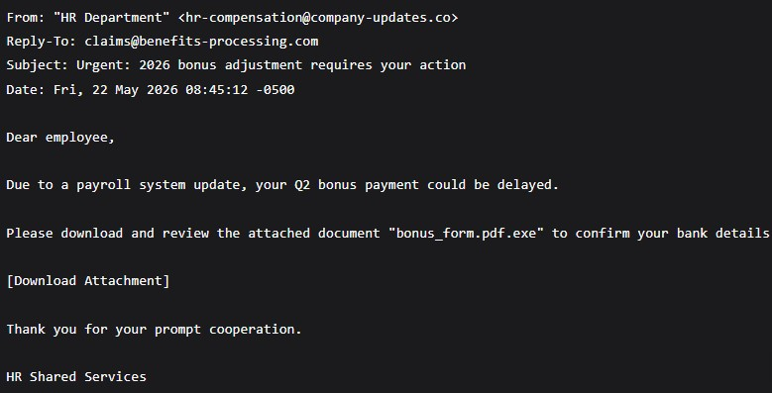

Indicators identified:

| Indicator | Detail | Risk Level |
Indicator | Detail | Risk Level
Sender domain | `company-updates.co` – not the organisation's legitimate domain | High
| Reply-To domain | `benefits-processing.com` – unfamiliar third‑party domain | High
Urgency | “could be delayed”, “requires your action” | Medium
Attachment name | bonus_form.pdf.exe` – double extension hiding an executable | Critical
Lack of personalisation | Generic “Dear employee” | Low
No contact information | No phone number or internal HR reference | Medium

Why the attachment is dangerous:
Microsoft Windows, by default, hides known file extensions. A user with default settings would see only `bonus_form.pdf` because `.exe` is a known extension type. The file is actually an executable program. If opened, it could:
- Install ransomware that encrypts all files.
- Install a keylogger to capture passwords.
- Give the attacker remote access to the computer.
- Spread to other computers on the same network.

Business‑friendly explanation:
“This email claims to be from HR, but the sender’s address does not match your company’s real domain. The attachment is named ‘bonus_form.pdf.exe’ – that is not a PDF document, but an executable program disguised as a PDF. Opening it could install malware or ransomware. Real HR departments never send executable files as attachments, and they would never ask you to confirm bank details via an unsolicited email.”

Why classified as ‘Suspicious’ and not ‘Phishing’:
While the email shows strong indicators of malicious intent, it does not contain an active link and the attachment has not been executed or scanned. The classification “Suspicious” is used to indicate that the email should be treated with extreme caution but requires further investigation (e.g., scanning the attachment in an isolated sandbox). For most users, the correct action is to delete the email and report it to IT.

4.3 Sample 3 – Safe Tech Today Newsletter

Email content (anonymised):
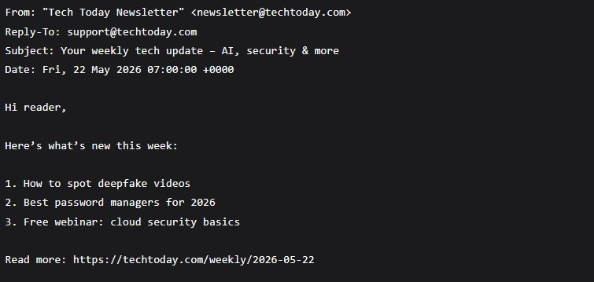
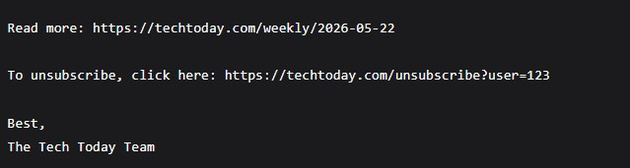

Indicators of safety:

| Indicator | Detail | Confidence |
Indicator | Detail | confidence
Sender domain | `techtoday.com` – matches the organisation name | Legitimate
Reply-To | Same domain (`support@techtoday.com`) – consistent | Legitimate
Links | Plain‑text, full URLs that clearly show the destination | Safe
Unsubscribe option | Included and functional – required by anti‑spam laws | Legitimate
No urgency | No threats, no deadlines, no “verify now” pressure | Safe
Language | Informative, neutral, no emotional manipulation | | Safe |

Link scan result:
The link `https://techtoday.com/weekly/2026-05-22` was submitted to VirusTotal. It received zero detections from all 92 vendors. The domain reputation is clean.

Business‑friendly explanation:
“This is a legitimate newsletter from Tech Today. The sender’s email address uses the real company domain, the links are clearly shown (not hidden behind shortened URLs), and there is no urgent demand to click anything. The email also provides an unsubscribe option, which is a good sign of a legitimate marketing email.”

-
## 5. Classification Summary

Sample | Key Indicators | Classification | Justification
PayPal | | Fake domain (`paypa1.com`), urgent threat, shortened malicious link flagged by VirusTotal | Phishing | Confirmed malicious intent – credential harvesting
HR benefits | Suspicious domain, double‑extension executable attachment, urgency | Suspicious | | High risk but no link; attachment not scanned; treat as malicious
Tech Today newsletter | Correct domain, plain links, no urgency, unsubscribe option | Safe | All indicators legitimate; no red flags

6. Phishing Techniques Explained (Business‑Friendly)

This section explains common phishing techniques in language suitable for all employees, regardless of technical background.

6.1 Typosquatting (Fake Domains)

Attackers register domain names that look almost identical to real ones, hoping you won’t notice the difference.
- Example: `paypa1.com` instead of `paypal.com` (digit 1 vs letter l)
- Example: `rnicrosoft.com` instead of `microsoft.com` (r instead of m)

How to spot it: Always check the sender’s full email address – not just the display name. Hover over the “From” name to reveal the actual address.

6.2 URL Obfuscation & Shortened Links

A link may display `https://paypal.com` in the email text, but the real destination is hidden. Attackers use:
- Shortened links (bit.ly, tinyurl.com) to hide malicious websites.
- Hyperlinked text – the visible text says one thing, the link goes somewhere else.

How to spot it: Hover your mouse over any link (without clicking). Look at the bottom left of your browser or email client – the real URL will appear. If it looks suspicious, do not click.

6.3 Urgency & Fear Tactics

Phishing emails try to bypass your rational thinking by creating panic. Common phrases:
- “Your account will be closed in 24 hours”
- “Immediate payment required”
- “Unusual login attempt – verify now”

How to spot it: Legitimate companies give you reasonable time to respond. When you see urgency, stop and think: is this how they normally communicate?

6.4 Spoofed Sender Addresses

Attackers can forge the “From” field to show a name you trust (e.g., your CEO), while the actual email comes from a free Gmail or Yahoo address.

How to spot it: Look at the email address inside angle brackets `<>`. Example: `"CEO Name" <ceo@gmail.com>` – that is not your CEO’s real email.

6.5 Malicious Attachments (Double Extensions)

Attackers name files like `invoice.pdf.exe` or `report.docm.js`. Windows hides the real extension by default, so you only see `invoice.pdf`.

How to spot it: If you receive an unexpected attachment, do not open it. Call the sender on a known phone number to verify they sent it. Also, configure Windows to always show file extensions.

6.6 Brand Impersonation
Attackers copy logos, colours, and formatting of well‑known brands (PayPal, Microsoft, Amazon, banks). They rely on your familiarity with the brand to lower your guard.

How to spot it: Even if the email looks perfect, check the sender’s email address. It’s easy to copy a logo; it’s hard to fake a legitimate domain.

6.7 Spear Phishing

Unlike generic phishing, spear phishing targets you personally. The attacker might know your name, role, recent purchases, or even your manager’s name. This information is often gathered from social media (LinkedIn, Facebook).

How to spot it: Personalisation alone does not make an email safe. Always verify unusual requests through a separate communication channel (e.g., call the person directly).

7. Prevention Guidelines for Employees
Follow these guidelines every time you check email.
7.1 Before Clicking Anything
- Check the sender’s full email address – not just the display name.
- Hover over links – the real destination must match what is written.
- Examine unexpected attachments – do not open them without verification.
- Look for spelling and grammar mistakes – many phishing emails originate from non‑native speakers.
- Verify with the sender – use a phone call or different email thread to confirm unusual requests.

7.2 Red Flags to Memorise
If you see… | It’s probably phishing
Your account will be suspended” | Phishing
“Click here to verify” | Phishing
An attachment named p’df.exe’.docm.js’ | Phishing
A shortened link (bit.ly, tinyurl) in an official email | Phishing
A generic greeting (“Dear Customer”) | Phishing
A request for your password or MFA code | Phishing

7.3 Safe Practices

- Use a password manager – it will not auto‑fill passwords on fake login pages.
- Enable Multi‑Factor Authentication (MFA) – even if your password is stolen, MFA blocks the attacker.
- Keep software updated – security patches fix vulnerabilities that malware exploits.
- Report suspicious emails – forward to your IT/security team. Do not delete them immediately – they may help protect others.
- Think before you click – take 5 seconds to examine every unexpected email.

8. What to Do If You Suspect or Fall for a Phishing Attack

8.1 If you suspect an email is phishing (but haven’t clicked)

- Do not click any links or open attachments.
- Do not reply to the email.
- Report it to your IT/security team (most organisations have a “Report Phishing” button in Outlook).
- Delete the email from your inbox and trash folder.

8.2 If you clicked a link but did not enter credentials
- Close the browser tab immediately.
- Run a full antivirus scan on your computer.
- Report the incident to IT – they may need to check for malware.
- Clear your browser cache and history.

8.3 If you entered your password on a fake page

- Immediately change your password for that account.
- If you reuse passwords (you shouldn’t), change all accounts that use the same password.
- Enable MFA if not already active.
- Check for unauthorised activity (login history, sent emails, bank transactions).
- Notify your IT/security team – they may need to revoke session tokens.
- Monitor your credit report if financial information was compromised.

8.4 If you opened a malicious attachment
- Disconnect the computer from the network (unplug Ethernet or turn off Wi-Fi).
- Do not restart the computer – this may trigger ransomware encryption.
- Contact your IT/security team immediately – they may need to isolate the device.
- If you are at home, run an offline antivirus scan using a trusted USB tool.
- Change passwords from a different, clean device.

9. Organisational Recommendations

While this report focuses on individual awareness, organisations should implement additional controls:
Control | Description | Priority
Email filtering | Use advanced spam filters that detect spoofing and malicious links | High
|DMARC, SPF, DKIM | Email authentication protocols that prevent domain spoofing | High
Link rewriting** | Rewrite all links in incoming emails to route through a security scanner | High

10. Real‑World Case Studies
Case Study 1: The $100 Million Google & Facebook Phishing Scam (2013‑2015)

An attacker named Evaldas Rimasauskas impersonated a legitimate Asian electronics manufacturer. He sent phishing emails to employees at Google and Facebook, using fake invoices and legitimate‑looking domains. Over two years, the two companies wired over $100 million to bank accounts controlled by the attacker. The scam was only discovered when the real manufacturer asked about unpaid invoices.

Lesson: Even tech giants can be fooled. Always verify payment requests through a second channel, even if the email looks perfect.

Case Study 2: The MGM Resorts Ransomware Attack (2023)

Attackers used a 10‑minute phone call to an MGM employee, combined with information found on LinkedIn, to gain initial access. That led to a full ransomware deployment that shut down hotel operations, casinos, and reservation systems for days. The cost exceeded $100 million.

Lesson: Phishing is not only via email – it includes voice (vishing) and SMS (smishing). Employee training must cover all forms of social engineering.

Case Study 3: Small Business Payroll Redirect (2024)

A small accounting firm received an email that appeared to be from a client, asking to change bank account details for future payments. The email used the client’s real logo and signature. The firm changed the details, and $50,000 was wired to the attacker. The client’s email had been compromised weeks earlier.

Lesson: Never change payment or bank details based on an email request. Call the requester at a known, trusted number.

11. Conclusion
Phishing remains one of the greatest cybersecurity threats because it targets the human element – not technical vulnerabilities. As this report has demonstrated, even a single malicious email can lead to credential theft, malware infection, or financial loss. However, with proper awareness and consistent precautions, most phishing attacks can be identified and avoided.

